11.73: a) There are several ways to find the tension. Taking torques about point B (the force of the hinge at A is given as being vertical, and exerts no torque about B), the tension acts at distance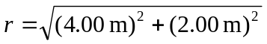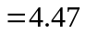m and at an angle of 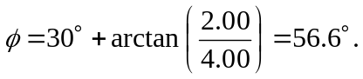 Setting . b) The hinge at A is given as exerting no horizontal force, so taking torques about point 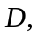 the lever arm for the vertical force at point so the horizontal force at 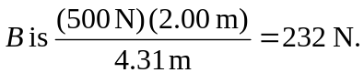 Using the result of part (a), however,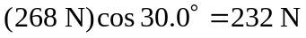 In fact, finding the horizontal force at first simplifies the calculation of the tension slightly. c) Equivalently, the result of part (b) could be used, taking torques about point 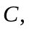 to get the same result.

